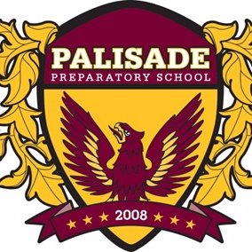8th Grade English Language Arts

Teacher: Miss Rraci

Email: [mrraci@yonkerspublicschools.org](mailto:mrraci@yonkerspublicschools.org)

Extra Help: Wednesdays, 2:40pm-3:15pm

**Course Overview:** Welcome to English! In this class, we will explore texts from a variety of writers who all have unique and exciting stories to tell. We will work collaboratively to not only study and analyze these works, but also tell stories of our own! This class will target student growth in reading comprehension, critical thinking skills, vocabulary building and successful writing. Throughout the course of this year, we will all engage in thought-provoking discussions that will assist us in developing these skills as well as finding our own writers’ voices! As a result, class participation is an *extremely* important part of this course and the most surefire route to student success.

**Assessment:** Student progress will be monitored through a variety of assessments in order to provide the best opportunity for *all*to succeed. Such assessments include homework assignments, in-class discussions/written responses, essays, projects, quizzes and exams. Students will also be taking the New York State ELA Exam in the spring of 2022. Students’ grades are calculated based on the following:

**35%** Essays/Projects

**25%** Classwork/Class Participation

**20%** Quizzes and Exams

**20%** Homework

*Extra credit opportunities will be provided throughout the year, and I am always available for extra help!

**Late Policy:** Students are expected to turn in assignments on the day that they are due. In the event that a student cannot meet an assignment deadline, said student is expected to *communicate* this with me – although points may be deducted, a late assignment is better than no assignment at all!

**Plagiarism:** I have a no-tolerance policy for plagiarized work and it will result in a zero. We will commit to academic integrity in this class.

**Electronic Devices:** Personal electronics (i.e. cell phones, tablets, etc.) are not permitted in class and will be confiscated. If there is an emergency that requires speaking to a student, parents/guardians are expected to contact the school.

**Our Community Agreements:** The eighth grade class has worked collaboratively with me to establish community agreements for the 2021-2022 school year. Because we created this list together, it is expected that *all* of us follow these guidelines in class **every day:**

* We will seek to **understand** differing perspectives, at times agreeing to disagree.
* We will be respectful, **active listeners** while our peers are sharing their ideas.
* We will work **collaboratively** by sharing ideas and helping each other when needed.
* We will maintain “good vibes”in our classroom by checking in with one another and **supporting** each other.
* We will be **kind** every day.

I am looking forward to an exciting and successful school year with you all!